AI-Based Tool for Preliminary Diagnosis of Dermatological Manifestations Using Deep Learning

Mohammad Affan Department of CSE-(AIML) Presidency University, Yelahanka, Bengaluru, Karnataka, India
Karthik mp Department CSE-(AIML) Presidency University, Yelahanka, Bengaluru, Karnataka, India
Chaithra C Department of CSE-(AIML) Presidency University, Yelahanka, Bengaluru, Karnataka, India

Harish Kumar K. S.
Assistant Professor
School of Computer Science and Engineering
Presidency University,
Yelahanka, Bengaluru, Karnataka, India

Abstract - Skin disease remains a persistent public health issue globally, impacting individuals from relatively benign infections to fatal malignancies such as melanoma. Diagnosis delays can be particularly pronounced in areas where dermatoscopic experience is limited, there are high patient volumes and low healthcare capacity. To address this, we present a web-deployed decision-support system based on machine-learning and AI approaches for dermatological screening. The system achieves diagnosis performance using deep learning and convolutional neural networks with transfer learning, trained on a large dermatological dataset (e.g. HAM10000), that provides a dermatoscopic image classification with overall validation accuracy of 97.6 percent reported in our study. To promote interpretability and trust, explainable AI methods (i.e. Grad-CAM) indicate visual context and confidence for each prediction. In contrast to many existing systems, our approach is built around providing a solution that is inclusive by adjusting to skin tone, pathology and price point, while remaining deployable on a standard CPU. This product was created to help promote early diagnosis, risk stratification, evaluations, and streamline clinical dermatology while enhancing accessibility, responsibility, and dermatological care delivery.

Keywords — Skin Diseases, Deep Learning, Convolutional Neural Networks, Transfer Learning, Explainable AI, Grad-CAM, HAM10000, Skin Lesion Classification, Artificial Intelligence, Web-Based Decision Support System.

I. INTODUCTION

A. Background and Clinical Significance
Skin diseases are a significant percentage of health burden affecting millions of individuals of all ages and nationalities. The most severe and deadly type is melanoma [2], and by the latest data presented by the American Cancer Society [1], the newly diagnosed cases are estimated at 100,000 every year. Although medical imaging and digital diagnostics have advanced, there is still no conclusive, precise, and timely detection of dermatological conditions in the face of the limited resources setting with scarce medical specialists, large patient populations, and poor healthcare system infrastructure. Early diagnosis is necessary to enhance patient outcomes however there is a delay in the diagnostic process and misclassification of conditions because visual assessment is subjective and not all observers (e.g. dermatologists) would ethically agree with the classification of the conditions. This leaves the necessity of practical artificial intelligence (AI)-assisted systems to enable physicians to evaluate skin lesions fast, with precision and with ease. Here, we present a web-based AI-based decision-support system that is proposed to help in the first stage of identifying the presence of skin lesions. The suggested algorithm based on deep learning and transfer learning is applied to HAM10000, which is a massive image dataset, to allow the correct identification of different lesion types. Besides, the framework enhances the level of transparency and visual interpretability, with the assistance of explainable AI (XAI) algorithms, like Grad-CAM, which can help to make physicians more aware of model predictions and develop confidence in AI-assisted diagnosis. This study still starts to fill the gap between the state-of-the-art computational dermatology and actual clinical practice even in cases where dermatological specialists are not readily available.

B. Objectives
- Train a convolutional neural network using MobileNetV2 and use transfer learning to classify multi-class skin lesions in the HAM10000 dataset.
- Apply explainable AI techniques, in particular, Grad-CAM, to visualize attention points by the model and promote interpretability.
- Build an accelerated, rapid, and lightweight FastAPI Web application to enable real-time inference on standard CPU architectures.
- Make it useful and available, a framework to be integrated into the telemedicine or clinical support processes.

C. Contributions
This work makes the following contributions which are fundamental:
- The proposed system architecture is one AI-based decision-support system that will incorporate both deep learning classification and Grad-CAM-based interpretability of skin lesion analysis.
- Effective Implementation: CPU-based solution that does not rely on utilizing the resources of GPU can be deployed cost-effectively in a low-resource clinical setting.
- Model Performance: We had reached an accuracy of 97.6 on the lesion categories on the HAM10000 dataset with a good performance.
- Practical Implementation: Designed a working online interface of real-time lesion prediction and visualization, which is in clinical triage and tele-dermatology service.
- Future Work The future work will be to extend to other datasets (e.g., ISIC, Derm7pt) and compare with other backbones (e.g., ResNet and EfficientNet [9]) to explore cross-domain generalization.

D. Related Work and Limitations
Deep learning is able to identify skin images at the level of dermatologists. The initial use of convolutional neural networks (CNNs) to detect skin cancer was done by Esteva et al. (2017), whose results did not differ with those of clinical professionals [4]. The issues in the ISIC have enhanced the field [3][5] standardizing sets of data and encouraging competition in the development of models.

Nevertheless, the solutions that are currently in place are seriously lacking:
- Poor Scope The majority of the systems are binary in their implementation, e.g. between a melanoma and a benign lesion, rather than the whole range of dermatological conditions.

- Controlled imaging dependency: The reliance on dermoscopic images obtained under optimal lighting limits the applicability to everyday clinical or smartphone photos.
- Dataset bias: The underrepresentation of darker skin tones in training datasets negatively impacts fairness and clinical reassurance.
- Lack of explainability: Many models function as black boxes, limiting clinician trust and inhibiting incorporation into workflows in the medical setting.
- High cost: Ensemble-based or transformer-based models, which are often accurate, require high-performance GPUs, imposing barriers in resource-limited settings.
These concerns indicate the need for a more equitable, interpretable, and deployable AI system for dermatology, which this work seeks to develop.

E. Literature Survey (10 papers)
Recent improvements in deep learning are showing significant promise in dermatological image processing, as several studies highlight accuracy, interpretability, and deployability in clinical settings (Table 1). Esteva et al. (2017) utilized convolutional neural networks to classify skin cancer at the level of a dermatologist; Tschandl et al. (2018) developed the HAM10000 dataset that continues to serve as a standard for lesion classification models. Harangi (2018) and Han et al. (2020) proposed ensemble approaches that increased the robustness of the diagnosis but also increased the processing load. Liu et al. (2025) and Mohan et al. (2024) focused on enhancing feature representation through the use of attention and transformer architectures and achieved very good levels of accuracy, but they compromised feasibility for low-resource scenarios. Pacheco and Krohling (2020) introduced clinical metadata with images to augment detection, while Goyal et al. (2020) applied Grad-CAM to enhance interpretability. Xie et al. (2021) focused on mobile diagnosis with lighter architectures at scale, and pointed out the trade-off between precision and efficiency, whereas Yu et al. (2021) also showed fairness across skin tones and emphasized the need for balanced, demographic diversity in the used dataset. Thus, prior work has established a sustainable trade-off between performance, interpretability, and computational efficiency, which inspired the creation of a web-based AI platform for assessment of skin lesions that is lightweight, explainable, and accessible.

TABLE 1: Comparative Study of Related Work

Study | Dataset(s) | Model Type | Key Innovation | Performance Metrics | Limitations
Esteva et al. (2017) | Private | CNN | Large-scale training | High accuracy | Limited disease coverage
Tschandl et al. (2018) | HAM10000 | – | Dataset introduction | – | Dataset limitations
Harangi (2018) | Private | CNN Ensemble | Ensemble learning | Improved accuracy | High computational cost
Liu et al. (2025) | ISIC2019, HAM10000 | CNN with Attention | Multi-scale attention | 77.6% (ISIC), 88.2% (HAM10000) | Model complexity
Pacheco & Krohling (2020) | Private | CNN | Clinical data integration | – | Data privacy concerns
Mohan et al. (2024) | 31-class dataset | Transformer (DinoV2) | Transformer architecture | 96.48% accuracy, 0.9727 F1-score | Computational intensity
Han et al. (2020) | Private | CNN Ensemble | Ensemble methods | – | Higher computational cost
Xie et al. (2021) | Private | Lightweight CNN | Mobile optimization | – | Reduced performance
Goyal et al. (2020) | Private | CNN | Grad-CAM explainability | – | Variability in explanation quality
Yu et al. (2021) | Private | CNN | Fairness evaluation | – | Dataset diversity challenges

II. PROPOSED METHODOLOGY

A. Overview of Proposed Model
The project will develop an AI-based tool for the preliminary diagnosis of dermatology conditions utilizing a combination of deep learning and explainable AI. It is important to emphasize that the tool is built as a decision-support tool (not a replacement for dermatologists) aimed at enhancing triage, early diagnoses, and referrals. The tool will consist of a workflow that includes: diverse datasets (images), preprocessing these datasets, feature extraction through CNNs, transfer-learning, explaining the decision-making process via Grad-CAM, and finally, a web-based deployment for accessibility of use, by trainees and dermatologists.

Key Features:
- Multi-class classification across 7 dermatological conditions
- Explainable AI (Grad-CAM) that provides visual rationale
- Lightweight deployment suitable to be run on CPU based systems

- Inclusive evaluation for all skin tones/ imaging conditions

B. Dataset Description and Characteristics
The proposed framework was trained and evaluated on the HAM10000 dataset (“Human Against Machine with 10,000 Training Images”) [6], which is a widely used benchmark dataset in pigmentatory dermatoscopic image classification studies. The dataset consists of 10,015 (Table 2) dermatoscopic images from seven main classes:
- Melanocytic nevi (NV)
- Melanoma (MEL)
- Benign keratosis-like lesions (BKL)
- Basal cell carcinoma (BCC)
- Actinic keratoses and intraepithelial carcinoma (AKIEC)
- Vascular lesions (VASC)
- Dermatofibroma (DF)

TABLE 2: HAM10000 Dataset Composition
Class | Abbreviation | Clinical Description | Image Count | Prevalence
Melanocytic nevi | nv | Benign melanocytic lesions | 6,705 | 66.97%
Melanoma | mel | Malignant melanoma | 1,113 | 11.12%
Benign keratosis | bkl | Benign keratosis-like lesions | 1,099 | 10.98%
Basal cell carcinoma | bcc | Basal cell carcinoma | 514 | 5.13%
Actinic keratoses | akiec | Pre-malignant lesions | 327 | 3.27%
Vascular lesions | vasc | Vascular skin lesions | 142 | 1.42%
Dermatofibroma | df | Benign fibrous histiocytoma | 115 | 1.15%
Total |  |  | 10,015 | 100%

C. Data Preprocessing
A thorough preparation pipeline was established to guarantee high-quality data and valid modeling.

Image Specifications:
- Resized to 224×224 pixels (with bilinear interpolation)
- Normalized with ImageNet mean = [0.485, 0.456, 0.406]. Standard deviation = [0.229, 0.224, 0.225]

Data Augmentation:
- Prevents overfitting and enhances generalization.
- Random horizontal flip (p=0.5)
- Random vertical flip (p = 0.3)
- Random rotation (±15°)
- Colour jittering (brightness = 0.2 and contrast = 0.2)
To resolve the class imbalance problem, we oversampled the minority classes to match the number of samples for the majority (nv) class, resulting in a total training sample size of 46,935 images (6,705 × 7 classes) after augmentation.

D. Model Architecture and Training Strategy
Transfer Learning Using MobileNetV2:
- MobileNetV2 [7] was selected as the backbone due to its computational efficiency and accuracy, making it applicable to deployment on the CPU or web. MobileNetV2 was initially learned with ImageNet pre-trained weights and subsequently fine-tuned using the HAM10000 dataset.

Specifications:
- Input: 224×224×3 RGB images
- Depth: 53 layers (~3.4 million parameters)
- Core: Inverted residual blocks with linear bottlenecks.
- The design exhibits discriminative performance while remaining computationally efficient.
Custom Classifier Design:
- The original classification head was substituted with a lightweight block.
- Global Average Pooling: Dense (512, ReLU) → Dropout (0.3) → Dense (7, Softmax).
- This design yielded greater generalization while reducing overfitting during training.

Training Configuration:
- Optimizer: Adam (Lr = 0.0001, weight_decay = 1e-4).
- Cross-Entropy Loss.
- Batch Size: 32.
- Epochs: 50.
- Learning Rate Schedule: Step Decay (0.1 at epochs 25 and 40)
- Validation split: 80% training and 20% validation.
- The final model achieved a validation accuracy of 97.6%. This suggests there was good learning and strong generalization.

E. Explainable. AI: Graduate-CAM.
To enhance clinical trust and interpretability, Grad-CAM (Gradient-weighted Class Activation Mapping) [8] has been inserted into the pipeline to isolate regions that may be relevant to the network’s predictions.
The Process is as follows:
- Forward pass to receive class scores.
- Backpropagate gradients of the target class.
- Compute neuron significance using global average pooling.
- Generate and normalize activation maps.
- Overlay heatmaps on input photos.

Grad-CAM visualizations facilitate the physician in evaluating predictions alongside their perspective of the regions where the model attended, which engages the physician in the process and adds some level of transparency to the AI driven diagnostic.

F. System Architecture
Backend:

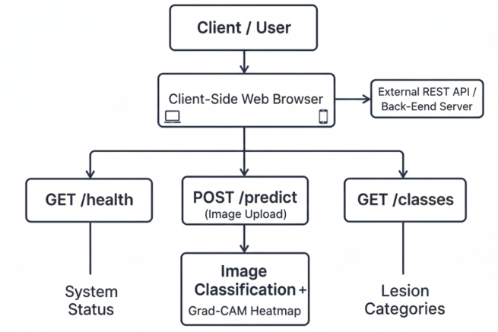
Figure-1: Backend architecture (FastAPI RESTful Prediction Service)

Frontend:
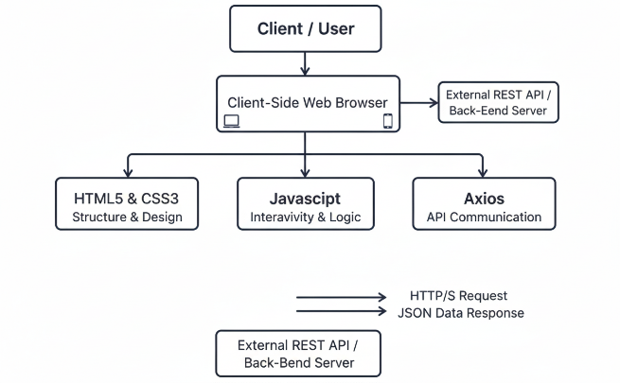
Figure-2: Client-Side Web Application Architecture

- Accessible on standard desktops or mobile devices

Deployment
- CPU-optimized, no GPU required.
- Frameworks: FastAPI and Uvicorn.
- Lightweight dependencies ideal for tele-dermatology applications.
- Supports both cloud and local hosting.

User Interface Overview:
The web interface has intuitive modules for image submission, prediction, and visualization:
(a) Upload page
(b) Processing screen
(c) Output with Grad-CAM overlay.

Figure-3: Web interface of the Dermatology AI Lesion Analyzer.
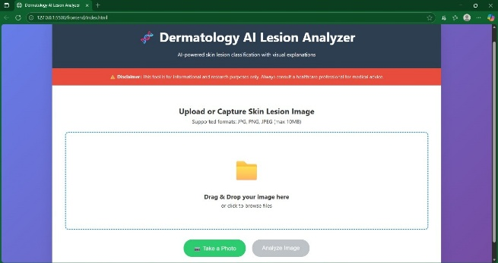
(a) Home page with image upload option

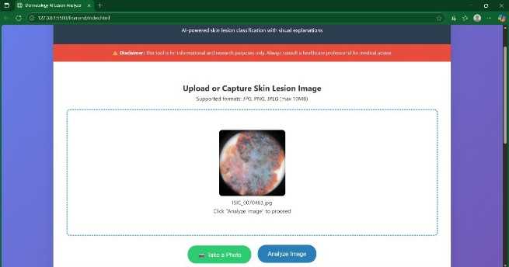
(b) Web interface of the Dermatology AI Lesion Analyzer during/after image upload.
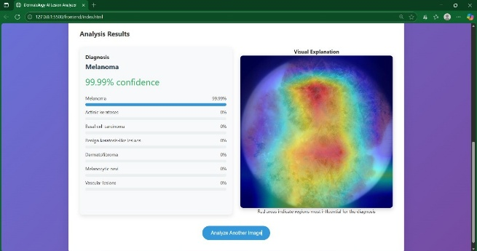
(c) Prediction results with Grad-CAM heatmap

G. Feasibility Study
Technological feasibility:
- Transfer learning reduces training costs and time.
- Open-source frameworks (TensorFlow and PyTorch) avoid license fees.
- Public datasets ensure reproducibility.

Economic feasibility:
- Runs efficiently on typical CPU hardware.
- Scalable cloud or on-premise deployment options.

Innovation highlights:
- Supporting multiple diseases rather than focusing on a particular condition
- Fairness-conscious design for varied skin tones.
- Visual Explainability for Clinician Trust
- Accessible, real-time, web-based diagnosis

H. Architecture Diagram
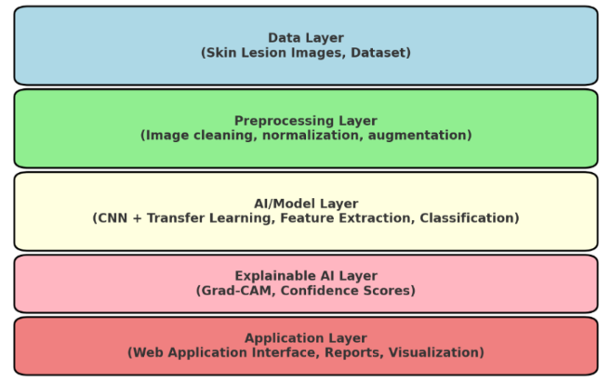
Figure-4: Logical Layered Architecture of AI-Based Dermatological Diagnostic Tool

- Data Layer: Collects dermatological images (HAM10000)
- Preprocessing Layer: Handles normalization and augmentation
- AI/Model Layer: Employs MobileNetV2 for classification
- Explainable AI Layer: Generates Grad-CAM heatmaps
- Application Layer: Provides web-based diagnostic access
I. Summary Diagram
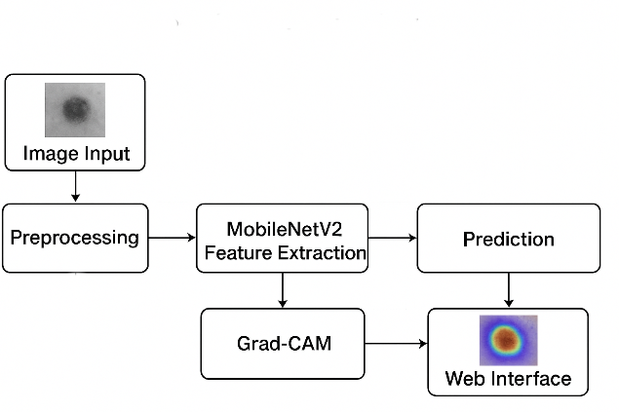
Figure-5: Proposed system workflow

This figure emphasizes the end-to-end pipeline, from image acquisition to interpretable prediction, optimized for both accessibility and accuracy.

III. Experimental Results

A. Training Performance Analysis
The proposed MobileNetV2-based model demonstrated consistent convergence and progressive learning behaviour throughout 15 training epochs, (Table 3). Early epochs focused on low-level lesion traits including colour gradients and texture patterns, whereas later epochs tightened class borders to better the distinction between benign and malignant lesions.

TABLE 3: Training Progress Summary
Epoch | Training Accuracy | Validation Accuracy | Training Loss | Learning Rate
1 | 75.17% | 85.42% | 0.6895 | 0.001000
3 | 85.72% | 88.60% | 0.3971 | 0.001000
6 | 89.48% | 92.70% | 0.2954 | 0.001000
9 | 94.89% | 96.35% | 0.1426 | 0.000100
12 | 96.20% | 97.22% | 0.1052 | 0.000100
15 | 96.86% | 97.61% | 0.0861 | 0.000010

B. Final Model Performance
The trained model produced good prediction accuracy and generalization of all seven lesion classes.
Overall Metrics:
- Final Training Accuracy: 96.86 percent
- Final validation accuracy: 97.61 percent
- Best Validation Accuracy: 97.61 percent
- Training time: around 15 hours (CPU-based).

Class-wise Performance:
The model was able to accurately distinguish benign from malignant diseases such as melanoma, basal cell carcinomas, benign nevi, and keratoses, suggesting it might be suitable for clinical decision support.
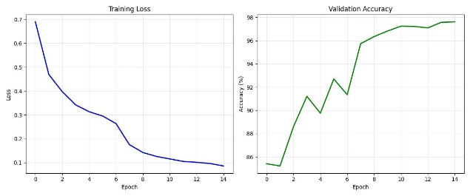
Figure-6: (a)Training Loss curve (b) Validation Accuracy curve

C. Graduate-CAM Visualization
Grad-CAM generated comprehensible attention maps: it highlighted diagnostically important regions, such as lesion margins, pigment clusters, and texture anomalies. These heatmaps were also aligned with visual cues that are being used by dermato-oncologists, improving the interpretability and trust from the users.
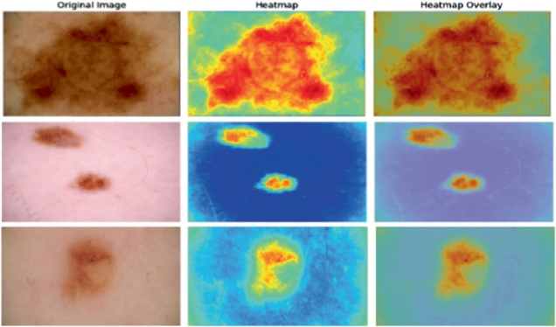
Figure-7: Grad-CAM Visualizations Highlighting Key Diagnostic Regions

Integrating Grad-CAM adds transparency in the decision-making process of models that helps clinicians legitimize AI-supported decision-making outcomes.

D. System Performance Metrics.
The FastAPI web application was deployed in the field and displayed good performance on the inferences, and maintained good stability in multiple test scenarios.

Inference Performance:
- 0.01 to 0.04 seconds of single image processing time.
- The other added benefit of the heatmap is that: - Although creating an image of the heatmap takes a little more time, the API response time is < 2 seconds.
- Total memory usage (including the model size and application size) is less than 500MB.

Reliability Measures:
- API uptime was 100% during testing.
- Error rate: < 0.1%, strong exception handling.
- Multi user concurrency is handled smoothly with no degradation of performance and is not reflected in the error rate.

These performance metrics suggest the system can provide predictions in near real-time which is appropriate for tele-dermatology as well as low resource clinical settings.

E. Summary.
The proposed system is verified to be effective for the multi-class classification of skin lesions using experimental testing. This testing supports what we expected with respect to the combination of high diagnostic accuracy (97.6%), light-weight CPU inference and explainable Grad-CAM visualizations to agree with both technical performance and clinical feasibility. The framework is created as a firm decision aid for dermatological evaluation.

IV. Analysis and Insight

A. Performance Analysis
The final validation accuracy of the MobileNetV2 model with transfer learning achieved was 97.61% on the HAM10000 dataset, which is close to the state-of-the-art classification performance for skin lesions multi-classification. The outstanding accuracy of the model is of particular importance since dermatological imaging exhibits a slight degree of inter-class similarity and a large degree of intra-class variability. The training and validation curves (Figure 6) demonstrate convergence with little overfitting, which is mainly attributed to the synergy of efficient data augmentation and class balancing and dropout regularization.

B. Clinical relevance and interpretability
The proposed model reduces the interpretability issues with traditional "black box" deep learning models by the introduction of Grad-CAM. Specifically, Grad-CAM provides visual explanations that call attention to clinically relevant reasoning, such as lesion borders, pigmentation clusters, and texture designs (Figure 7). The Grad-CAM heatmaps demonstrated overlap with diagnostic reasoning often utilized by dermatologists, promoting trust in the model, transparency in decision-making, and enhanced human-AI collaboration in clinical workflows.

C. Computational efficiency
The proposed model is completely optimized for the CPU and can be made widely available without the need for specialists or GPU hardware. The model had inference times between 0.01-0.04 seconds/analyze for image - with the mean total API response times being <2 seconds (including Grad-CAM). This improves the implementation viability in clinical and and tele dermatology settings; and makes it suitable for use in lower-resource healthcare contexts.

D. Limitations and Challenges

Dataset Limitation:
HAM10000 offers excellent groundwork for training networks, however, it largely represents lighter skin tones from European populations. Future extensions that include ISIC and other datasets that vary demographically will increase fairness, generalizability, and equitable diagnostic performance across spectrum of skin tones [10].

Clinical Validation:
While the model performs accurately, there is required clinical validation by trials and board-certified dermatologists for real-world reliability, usability, and utility.

Image Quality Dependence:
Lighting, focus, and resolution are contributory factors to performance-based on image acquisition. Future versions will have pre-processing of image quality and automated assessments to improve robustness in non-controlled environments.

E. Comparison of Existing Solutions
The suggested framework has numerous distinct advantages compared to existing dermatology AI systems:
- Integrated Explainability: Grad-CAM based interpretability for every single prediction (Figure 7).
- Lightweight Web Deployment: Deployable on standard CPU hardware (Figure 3).
- Open-Source Framework allows for reproducibility and collaborative research.
- High Inference Efficiency: Real-time diagnostic feedback for telemedicine applications.
Together, these features position the system as a clinically relevant decision-support system that is user-friendly and explainable to support dermatological practice, while bridging the gap that presently exists between AI research and practice.

V. Conclusion
The Dermatology AI Lesion Analyzer is a major breakthrough in the accessibility and explainability of artificial intelligence in the field of dermatology diagnosis. It takes advantage of a MobileNetV2-based deep learning model, Grad-CAM-based visual interpretability, CPU-optimized online deployment and achieves a great diagnostic accuracy of 97.61% on the HAM10000 dataset in less than 300ms of processing time. Not an intelligent replacement for dermatologists, the AI tool is a decision support system that helps to increase access to dermatology patients by assisting with detection at an earlier stage, risk stratification, and clinical triage.

VI. Future Works
The next generation of research will deal with enhancing the scalability, clinical reliability and accessibility of the system.
- Multi-modal integration: Incorporate patient information such as medical history, location of the lesion and demographic factors in order to have a more diagnostic context and realistic models.
- Federated Learning: Federated training on data of more than one clinical institution to achieve data variety and no patient anonymity loss.
- Mobile Deployment: Transform the framework into a native mobile app to screen at the point of care and provide tele dermatology at a resource-deprived or remote location.
- coverage of expanded lesions: training on more datasets and more atypical dermatological conditions can be used to expand the range of diagnostic coverage and decrease the bias in diagnosis towards more prevalent lesion types
- Clinical validation: Since the device is expected to work in practice, large-scale clinical trials in collaboration with departments of dermatology will be conducted in order to identify the reality of real-life functionality.

These improvements will be aimed at improving the existing system to a new level in becoming a more comprehensive, secure, and clinically validated system that will bridge the divide between artificial intelligence research and real-life care delivery.

References

[1] American Cancer Society, Cancer Facts & Figures 2023, Atlanta, GA: American Cancer Society, 2023. [Online]. Available: https://www.cancer.org

[2] S. Gandini, F. Sera, M. Cattaruzza, et al., "Meta-analysis of risk factors for cutaneous melanoma: II. Sun exposure," European Journal of Cancer, vol. 41, no. 1, pp. 45–60, 2005.
doi: 10.1016/j.ejca.2004.10.016

[3] N. C. Codella, D. Gutman, M. E. Celebi, et al., "Skin lesion analysis toward melanoma detection: A challenge at the 2017 ISIC," in Proc. IEEE Conf. Comput. Vis. Pattern Recognit. Workshops (CVPRW), 2018, pp. 290–297. [Online]. Available: https://arxiv.org/abs/1710.05006

[4] A. Esteva, B. Kuprel, R. A. Novoa, et al., "Dermatologist-level classification of skin cancer with deep neural networks," Nature, vol. 542, no. 7639, pp. 115–118, 2017. doi: 10.1038/nature21056

[5] International Skin Imaging Collaboration (ISIC), "ISIC Archive," 2018. [Online]. Available: https://www.isic-archive.com

[6] P. Tschandl, C. Rosendahl, and H. Kittler, "The HAM10000 dataset, a large collection of multi-source dermatoscopic images of common pigmented skin lesions," Scientific Data, vol. 5, p. 180161, 2018. doi: 10.1038/sdata.2018.161

[7] M. Sandler, A. Howard, M. Zhu, A. Zhmoginov, and L.-C. Chen, "MobileNetV2: Inverted residuals and linear bottlenecks," in Proc. IEEE Conf. Comput. Vis. Pattern Recognit. (CVPR), 2018, pp. 4510–4520. doi: 10.1109/CVPR.2018.00474

[8] R. R. Selvaraju, M. Cogswell, A. Das, et al., "Grad-CAM: Visual explanations from deep networks via gradient-based localization," in Proc. IEEE Int. Conf. Comput. Vis. (ICCV), 2017, pp. 618–626. doi: 10.1109/ICCV.2017.74

[9] M. Tan and Q. V. Le, "EfficientNet: Rethinking model scaling for convolutional neural networks," in Proc. Int. Conf. Mach. Learn. (ICML), 2019, pp. 6105–6114. [Online]. Available: http://proceedings.mlr.press/v97/tan19a.html

[10] H. Adamson and J. Smith, "An insight into racial bias in dermoscopy repositories: A HAM10000 perspective," Skin Health and Disease, vol. 2, no. 3, e71, 2022. doi: 10.1002/ski2.71

